CivicConnect — PED v2.0: Architecture & Quality Drivers
How to use this: each numbered section below is written to paste into PED v2.0 as a continuation of M1 (not a separate M2 report). Text in [square brackets] needs your team's input or verification. Nothing from M1 is deleted: changes go through the change log in Section 1.

1. Document control and M1 baseline review (PED v2.0)
1.1 Version history (append to the M1 table, keep the original rows)
Version | Date | Author | Changes
0.1 | 06 September | Armand | Work split and format (M1, retained)
0.8 | 08 September | Team | Each member integrates sections (M1, retained)
1.0 | 09 September | Team | Verified M1 baseline for submission (M1, retained)
1.1 | 09 September | Person 1 | M1 review findings logged as change requests CR-001 to CR-003 (Section 1.2)
2.0 | 10 September | Team | Architecture, Technology & Initial Design Baseline: ASRs, architecture decision, ADR-001 to ADR-004, RTM evolution, updated risks and forward considerations
1.2 M1 baseline review: findings requiring controlled change
Reviewing M1 against what architecture now needs surfaced three issues. They touch baselined content, so they are raised as change requests, not silently edited (the M2 brief requires the original baseline and reason for change to be preserved).
CR | M1 item | Issue | Proposed change | Reason
CR-001 | NFR-024 / AC-024 | Requirement says "at least 95-98% of requests" but the acceptance criterion says 95%. The range is ambiguous and cannot be tested. | Restate as: "at least 95% of regular operations return feedback within 3 seconds under the expected load [define load]." Original wording retained in the change log. | A testable target is needed to evaluate architecture against ASR-5.
CR-002 | FR-015 | "Overdue" is required in reporting but M1 defines no due date or overdue rule (SLA escalation is deferred in Section 3.3). | Add a clarification: a request is overdue when [rule, e.g. unresolved after N working days by category]. Escalation remains deferred. | Overdue status needs a data attribute (due date / threshold). This affects the data model (Person 2) and the Reporting module.
CR-003 | AC-0010 (FR-010) | Identifier typo; all others use three digits (AC-001 to AC-016). | Correct to AC-010. | Traceability integrity.
Scope is unchanged by CR-001 to CR-003. Approval: [three sign-offs, recorded in the PR].
1.3 Assumptions and constraints carried forward
The M1 constraints (scope, schedule, cost, quality, security) remain in force. Two are now architecturally active:
- Cost/resources: M1 requires free-tier limits to be recorded as an explicit assumption. Architecturally this means a single deployable unit on a single host is the default assumption, to be revisited with the technology and deployment evidence (Person 2).
- Security/POPIA: M1 requires personal information to be handled lawfully under POPIA (Republic of South Africa, 2013). This becomes ASR-1 below.

2. Architecture Significant Requirements (ASRs) and quality drivers
An ASR is a requirement that has a measurable effect on the architecture: if it changed, the structure of the system would have to change (Bass, Clements and Kazman, 2021). Not all 24 M1 requirements qualify. Five do.
2.1 Selected ASRs
ASR | Quality attribute (ISO/IEC, 2011) | Driven by (M1 evidence) | Measurable expectation | Architectural consequence
ASR-1 Controlled access to request data | Security: confidentiality, authenticity | NFR-017, NFR-018, NFR-019, FR-007; Security constraint; Management-vs-privacy conflict (M1 §2.1); POPIA | 100% of protected operations are denied to unauthorised roles in automated tests; no data-returning endpoint lacks an authorisation check. | Authorisation is enforced on the server in one central place (deny by default), not in the UI and not scattered through feature code.
ASR-2 Trustworthy request lifecycle and audit trail | Security: accountability/non-repudiation; Functional correctness | NFR-020, FR-011, FR-012, FR-013; Management accountability need | Every status or ownership change produces exactly one audit record, written in the same transaction as the change; invalid status transitions are rejected 100% of the time in tests. | The lifecycle rules live in one domain component and the audit write is not optional or separable from the change.
ASR-3 No lost requests | Reliability: recoverability, fault tolerance | NFR-022, FR-003; Requester need "confidence the request will not be lost" | A request is persisted before confirmation is shown; 100% of confirmed requests retrievable by ID after a simulated application restart. | Persist-then-confirm flow; a durable relational store is the system of record; backup approach is a baseline concern (Person 2 owns the data decision).
ASR-4 Modifiability by a small team | Maintainability: modularity, testability | NFR-023; Schedule constraint; deferred scope (SLA escalation, SMS/email, analytics) | Adding a new notification channel or a new report touches one module plus configuration (verified by design review against the module map); each module is testable without the others running. | Enforced module boundaries with explicit interfaces; extension points where M1 deferred features will land.
ASR-5 Responsive everyday operations | Performance efficiency: time behaviour | NFR-024 (as clarified by CR-001); FR-008, FR-015 | At least 95% of regular operations give feedback within 3 s under [expected load]. | Filtering, searching and reporting must be served by indexed queries, not by loading and filtering in application memory.
2.2 Considered and deliberately not selected as ASRs
Naming what is excluded keeps this list from becoming a generic catalogue of every quality attribute taught.
- Usability (NFR-021): important, but it is satisfied in the presentation layer and does not change system structure.
- Scalability beyond a single instance: M1 lists scalability as a forward consideration but supplies no expected user volumes (its own "missing information"). Without a number, designing for horizontal scale would be unjustified complexity. It is recorded as a deferred decision (Section 8).
- Availability (e.g. 99.9%): no availability target exists in M1. Recorded as a risk and deferred decision, not an invented ASR.
2.3 How the ASRs drive decisions across the baseline
ASR | Architecture (Person 1) | Data (Person 2) | Technology (Person 2) | Design (Person 3)
ASR-1 | Central authorisation enforcement (ADR-003) | Ownership attributes on requests so access rules can be evaluated | Stack must support server-side role checks and sessions | Interface/guard approach
ASR-2 | Lifecycle in one component, audit co-located in transaction (ADR-004) | Append-only audit entity; transactional writes | Store must support ACID transactions | State/transition pattern candidate
ASR-3 | Persist-then-confirm; single system of record | Durable relational model, backup/recovery | Mature relational DB | Validation and unit-of-work approach
ASR-4 | Modular monolith with dependency rules (ADR-001, ADR-002) | Per-module data ownership | Build/test tooling per module | Notification extension point
ASR-5 | Query-side separation for reporting (within the monolith) | Indexes on filter attributes | Query capability of the store | Pagination/filter approach
Column entries for Persons 2 and 3 are proposals to align on; they should confirm or overwrite.

3. Architecture alternatives and decision
3.1 Alternatives considered
Option | Description
A. Layered monolith | One deployable, organised only by technical layers (presentation, business, data). The classic layered style (Richards and Ford, 2020).
B. Modular monolith | One deployable, organised by business modules with explicit interfaces and dependency rules, layered internally (Richards and Ford, 2020; Fowler, 2015).
C. Microservices | Independently deployed services per business capability, communicating over the network (Newman, 2021).
D. Backend-as-a-service / serverless-first | Managed platform supplies auth, database and functions; custom logic is thin and vendor-hosted.
3.2 Evaluation against drivers
Scores 1 (poor) to 5 (strong). Weights reflect M1 priorities: security and accountability were the drivers M1 explicitly protected in its Schedule-versus-Quality trade-off (M1 §4.1). These scores are team judgement, not measurement; [confirm or adjust as a team before sign-off, since you must be able to defend each one].
Criterion | Weight | A | B | C | D
ASR-1 Access control enforceable consistently | 20 | 4 | 4 | 3 | 3
ASR-2 Atomic lifecycle + audit | 20 | 5 | 5 | 2 | 3
ASR-3 Reliability (fewer failure points) | 10 | 4 | 4 | 3 | 4
ASR-4 Modifiability | 15 | 2 | 4 | 4 | 2
ASR-5 Performance | 5 | 4 | 4 | 3 | 4
Team capability / schedule | 15 | 5 | 4 | 1 | 4
Cost and deployability (free-tier assumption) | 15 | 5 | 5 | 1 | 4
Weighted score (out of 5) | 100 | 4.20 | 4.35 | 2.35 | 3.30
Reasoning behind the notable scores:
- C scores low on ASR-2: a status change and its audit record would span service boundaries, which forces either distributed transactions or eventual consistency. Both work against "exactly one audit record per change" (Newman, 2021).
- C scores lowest on team and cost: a three-person team carrying multiple deployables, inter-service networking and deployment pipelines is disproportionate. The M2 brief states that a more distributed architecture is not automatically more advanced.
- D scores lower on ASR-1/ASR-2/ASR-4: authorisation and audit rules would live in vendor-specific configuration, and M1's cost constraint already requires free-tier limits to be treated as a risk. [Person 2: confirm against the technology comparison.]
- A vs B is close (4.20 vs 4.35). The deciding factor is ASR-4: M1 has three deferred features (SLA escalation, external notifications, analytics) that need somewhere to land. Plain layers let business logic sprawl across features; module boundaries contain it, at the cost of discipline and a few extra interfaces.
3.3 Decision
Modular monolith (Option B): one deployable application, structured as business modules, each internally layered. See ADR-001. The rejected alternative to be ready to defend in the presentation is C (microservices).

4. Logical architecture
4.1 Modules and responsibilities
Module | Responsibility | Main M1 requirements
Identity & Access | Authentication, roles (Requester, Staff, Management/Admin), central authorisation decisions | NFR-017, NFR-018, NFR-019, FR-007
Request Management (core) | Submission, unique ID, lifecycle state rules, ownership/assignment, comments and resolution notes, request history views | FR-001, 003, 004, 005, 007 to 013
Category Management | Controlled category list; admin maintenance; validation that a request uses a valid category | FR-002, System Admin need
Audit | Append-only record of status, ownership and other major changes | NFR-020, FR-012, FR-014
Notification | In-app status feedback to requesters; extension point for deferred channels | FR-006
Reporting | Read-side queries for open, overdue, resolved, closed requests by category and status | FR-014, 015, 016
Module dependency rules (recorded in ADR-002):
- Modules talk to each other only through their published interface, never by reaching into another module's internals or tables.
- Dependencies point inward: presentation → application → domain; infrastructure implements interfaces defined by the inner layers (Martin, 2017).
- Request Management may call Audit, Notification, Identity & Access and Category Management. None of those may call Request Management. (Prevents circular dependencies.)
- Reporting is read-only and may read Request Management data through a query interface.
4.2 Logical diagram (Mermaid source; redraw in your diagramming tool of choice if preferred)
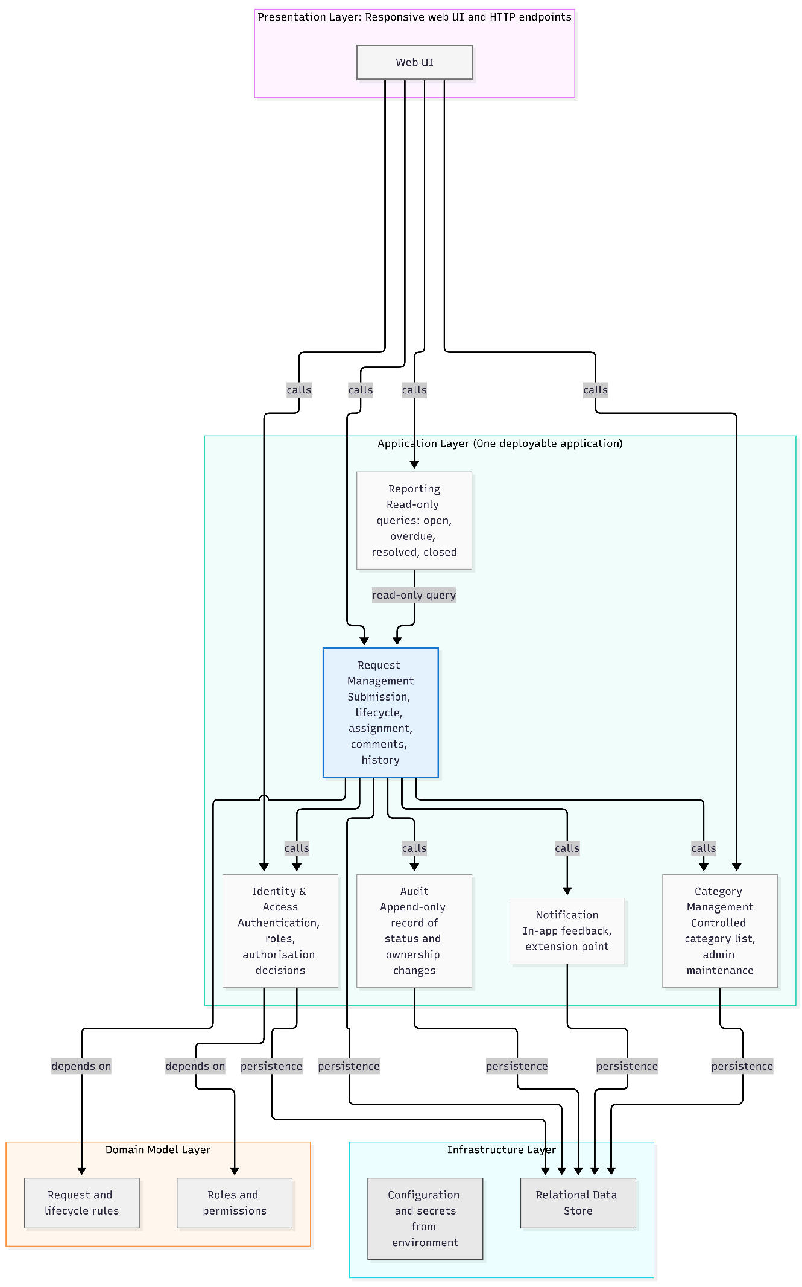
4.3 Request lifecycle (the rule enforced in one place, ASR-2)
M1 names the transitions Submitted → Acknowledged → In Progress → Resolved (M1 §2.1) and FR-006/FR-013 add rejected and closed outcomes. The exact transition table below is a proposal to confirm with the team, because M1 does not define it fully.
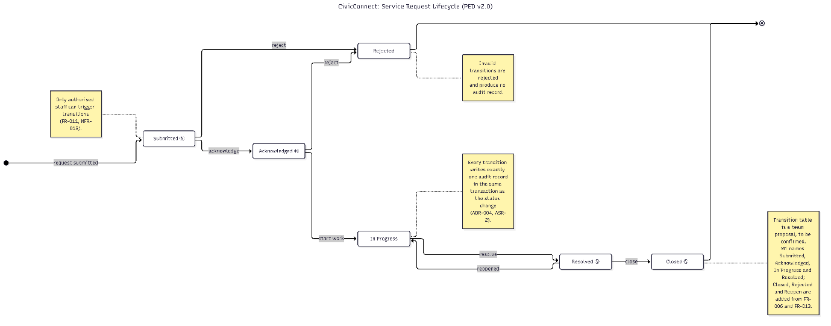
4.4 Physical deployment view (deliberately separate from the logical view)
The logical view above says how the code is organised. This view says where it runs. They are different things: several logical modules share one physical process (Kruchten, 1995; Brown, n.d.).
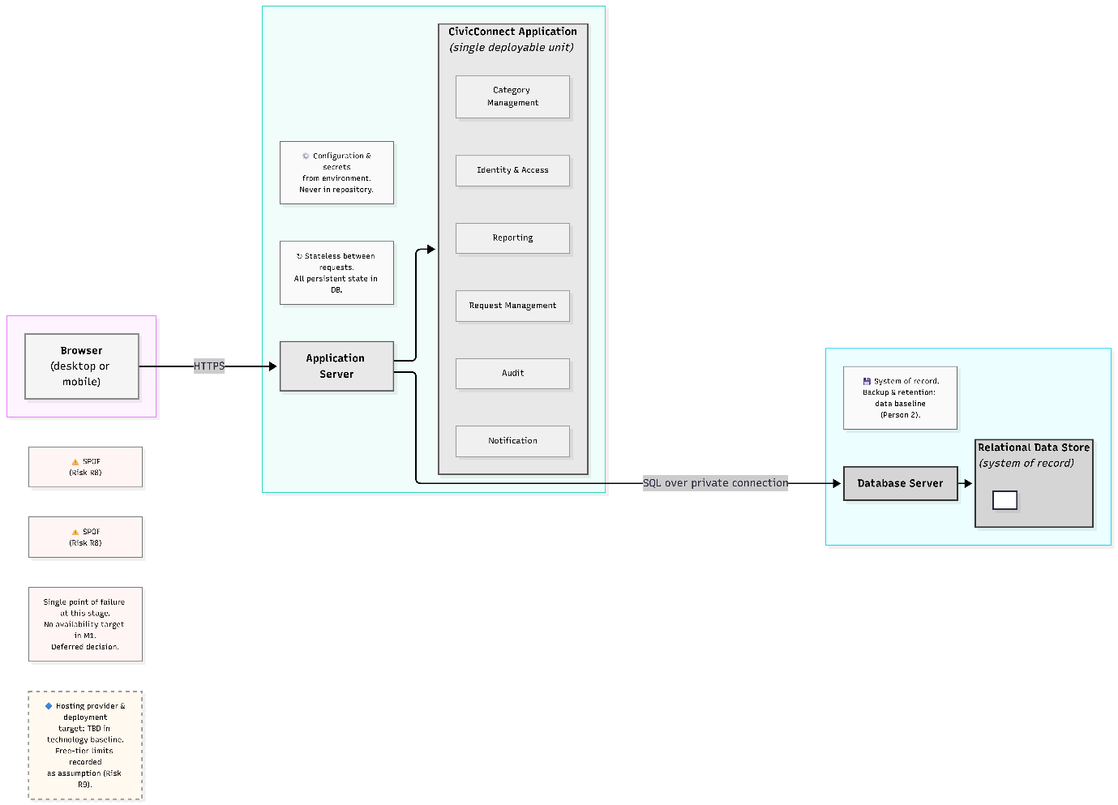
- Three physical tiers: browser, application server, database. One deployable application.
- Deployment target, hosting provider and exact technologies: not decided here. They belong to the technology baseline (Person 2) and the deployment compatibility section, and must be plausible against M1's free-tier assumption. The architecture is written to be technology-neutral so the A1 candidate stacks remain valid options.
- Known implications recorded: configuration and secrets come from the environment and are never committed; the database holds all persistent state, so the application tier stays stateless between requests; one application instance and one database are single points of failure at this stage (Risk R8).

5. Architecture Decision Records
Format adapted from Nygard (2011). Status values: Proposed / Accepted / Superseded. All four are Proposed until the team signs the baseline.
ADR-001: Modular monolith as the architectural style
- Status: Proposed | Date: [date] | Owner: Person 1
- Context: Three-person team, fixed milestones, free-tier cost assumption, and five ASRs dominated by security, atomic audit and modifiability (Section 2). Three M1 features are deferred and must be addable later.
- Decision: One deployable application structured as six business modules with enforced boundaries and internal layering (Section 4).
- Alternatives considered: A layered monolith (little protection against sprawl), C microservices (breaks atomic change-plus-audit, disproportionate operational load), D BaaS-first (rules held in vendor configuration, free-tier and lock-in risk). Scores in Section 3.2.
- Consequences: (+) transactions span modules, simple deployment, cheap to run, easy to test in-process. (−) modules share one deployment and one failure domain; boundaries depend on team discipline and code review rather than the network, so violations must be caught in PR review; scaling is whole-application.
- Evidence: Bass, Clements and Kazman (2021); Richards and Ford (2020); Fowler (2015); Newman (2021). [Week 2 teaching reference: insert lecture/slide.] [A2 reference if architecture/SCM research informed this: insert section.]
- If changed, affects: Section 4 diagrams, RTM module column, deployment assumptions, ADR-002 to ADR-004, risks R5 to R8.
- Revisit trigger: measured load breaching ASR-5, or an expected-volume figure that a single instance cannot serve.
ADR-002: Module decomposition and dependency rules
- Status: Proposed | Date: 30/9/2026 | Owner: Person 1
- Context: ASR-4 requires change isolation; NFR-023 requires well-defined component responsibilities.
- Decision: The six modules and four dependency rules in Section 4.1. Boundaries follow business capabilities rather than technical layers (Evans, 2004).
- Alternatives considered: Two or three coarse modules (less overhead, less isolation); one module per M1 requirement group (too granular for the team size).
- Consequences: (+) clear ownership and testability. (−) extra interfaces to maintain; Audit and Notification are small modules that may look over-split. Justified by their independent reasons to change (audit rules vs. future channels).
- Enforcement: folder/package structure mirrors modules; PR review checklist includes "no cross-module internals"; [optional: automated dependency check if the stack supports it, recorded once Person 2 confirms the stack].
- Evidence: Martin (2017); Evans (2004); Bass, Clements and Kazman (2021).
- If changed, affects: repository structure, README module map, RTM allocation column.
ADR-003: Central, deny-by-default server-side authorisation
- Status: Proposed | Date: 30/9/2026 | Owner: Person 1
- Context: ASR-1. Request data may be sensitive and must be protected under POPIA (Republic of South Africa, 2013). M1 selected role-based access control following the NIST/ANSI model (Sandhu, Ferraiolo and Kuhn, 2000; ANSI/INCITS, 2004). Broken access control is the most common web application weakness in the OWASP ranking (OWASP, 2021).
- Decision: Identity & Access is the only module that makes access decisions. Every protected operation passes through it on the server, and the default outcome is deny. UI hiding of controls is a usability aid only, never the control itself. Role checks are combined with ownership checks (e.g. a requester sees only their own requests).
- Alternatives considered: Per-feature ad hoc checks (inconsistent, hard to audit); UI-only restrictions (not a control at all); delegating entirely to a vendor policy layer (see ADR-001, option D).
- Consequences: (+) one place to review and test; matches the AC-017 to AC-019 acceptance evidence. (−) every new feature must route through it, and a bug there has wide impact, so it needs the strongest automated tests.
- Evidence: Sandhu, Ferraiolo and Kuhn (2000); ANSI/INCITS (2004); OWASP (2021); Republic of South Africa (2013), section 19 [verify section wording against the Act before submission].
- If changed, affects: NFR-017 to NFR-019 traceability, Identity & Access interface, every endpoint's test plan.
ADR-004: Lifecycle rules and audit record written in one transaction
- Status: Proposed | Date: 30/9/2026 | Owner: Person 1 (co-owned with Person 2 for the data aspects)
- Context: ASR-2 and ASR-3. Management needs reliable accountability data (M1 §1.3); the audit trail must not be able to drift from the actual state of a request.
- Decision: Status and ownership changes are applied only through Request Management's lifecycle rules (Section 4.3). The audit entry is written in the same database transaction as the change, so both succeed or neither does. Audit records are append-only: no edit or delete path is exposed.
- Alternatives considered: Audit written afterwards by a separate process or event (can lose entries on failure); database triggers only (logic hidden from code review, harder to test); no separate audit store, derived from current state only (loses history).
- Consequences: (+) audit integrity is structural, not procedural. (−) audit writes add a small cost to each change (acceptable against ASR-5); audit tables grow over time, so retention is an open data decision.
- Evidence: Bass, Clements and Kazman (2021); Fowler (2002) on domain logic organisation; [A2 persistence/transaction research section if used: insert reference].
- If changed, affects: data model (Person 2), NFR-020 traceability, Reporting (FR-014).
ADR candidate for the team to decide ownership of (overlaps Person 3's design decisions): in-app notification mechanism for FR-006, and how the extension point for deferred channels is shaped. Record as ADR-005 once Person 3's design patterns are final.

6. Risk Register additions (architecture-related)
Continues the M1 register (R1 to R4) using the same columns. Person 3 owns the register; these are submitted for merge.
ID | Risk | Probability | Impact | Priority | Mitigation | Owner | Contingency | Status
R5 | Module boundaries erode inside the monolith (shortcuts across modules) | Medium | Medium | Medium | ADR-002 rules, PR checklist item, folder structure mirrors modules | Architecture lead | Refactoring task scheduled before the next milestone | Open
R6 | Access control bypassed through an endpoint that skips the central check | Medium | High | High | ADR-003; authorisation tests per endpoint; review checklist | Team | Security review and fix before release; log as change | Open
R7 | Architecture over-engineered relative to the team's capacity | Low | Medium | Low | Proportionality principle (ADR-001); revisit if a module has no independent reason to exist | Architecture lead | Merge modules via a controlled ADR change | Open
R8 | Single application instance and single database are single points of failure; no availability target defined | Medium | Medium | Medium | Persist-then-confirm (ASR-3); backup approach decided by Person 2; record availability as a deferred decision | Team | Restore from backup; document recovery steps | Open
R9 | Free-tier hosting limits conflict with ASR-5 or ASR-3 | Medium | Medium | Medium | Record limits as a dependency assumption (M1 Cost constraint); measure early | Person 2 | Move to a paid tier or simplify reporting queries | Open

7. RTM: architecture columns (for M2 merge)
Adds the architecture columns to the M1 RTM. The M1 RTM grouped requirements by stakeholder; the per-requirement rows below are a finer-grained view suitable for tracing. Data, design, technology, implementation and verification columns are for Persons 2 and 3; use the controlled status "Planned" where evidence does not yet exist, and do not back-fill evidence that has not happened.
Req ID | ASR link | Architecture module(s) | ADR / risk ref
FR-001 | ASR-3 | Request Management; Category Management (validation) | ADR-001, ADR-004
FR-002 | ASR-4 | Category Management | ADR-002
FR-003 | ASR-3 | Request Management | ADR-004
FR-004 | ASR-1 | Request Management; Identity & Access | ADR-003
FR-005 | ASR-1, ASR-2 | Request Management; Audit | ADR-003, ADR-004
FR-006 | ASR-4 | Notification | ADR-002 (ADR-005 candidate)
FR-007 | ASR-1 | Request Management; Identity & Access | ADR-003, R6
FR-008 | ASR-5 | Request Management (query) | ADR-002
FR-009 | ASR-1 | Request Management; Identity & Access | ADR-003
FR-010 | ASR-1, ASR-2 | Request Management; Identity & Access; Audit | ADR-003, ADR-004
FR-011 | ASR-2 | Request Management (lifecycle); Audit | ADR-004
FR-012 | ASR-1, ASR-2 | Request Management; Audit | ADR-003, ADR-004
FR-013 | ASR-2 | Request Management (lifecycle); Audit | ADR-004
FR-014 | ASR-1, ASR-2 | Reporting; Audit | ADR-003, ADR-004
FR-015 | ASR-5 | Reporting | CR-002
FR-016 | ASR-5 | Reporting | ADR-002
NFR-017 | ASR-1 | Identity & Access | ADR-003
NFR-018 | ASR-1 | Identity & Access | ADR-003
NFR-019 | ASR-1 | Identity & Access; Request Management | ADR-003, R6
NFR-020 | ASR-2 | Audit | ADR-004
NFR-021 | none (not an ASR) | Presentation layer | n/a
NFR-022 | ASR-3 | Infrastructure (data store) | ADR-004, R8
NFR-023 | ASR-4 | All modules | ADR-001, ADR-002, R5
NFR-024 | ASR-5 | Reporting; Request Management (query) | CR-001, R9
Suggested end-to-end trace (required by the M2 brief, Section 9)
Pick one path the team will actually implement first. A strong candidate because it touches every ASR decision:
FR-011 (update status through controlled transitions) → ASR-2 → Request Management lifecycle rules + Audit → audit entity and transaction (Person 2) → state/transition design decision (Person 3) → technology and ADR-004 → [branch/class/endpoint] → [test showing an invalid transition is rejected and a valid one writes one audit record].
Fill the bracketed items only with real repository evidence. The brief explicitly penalises decisions with no visible application translation once implementation has begun.

8. Forward Engineering Considerations (updates) and deferred decisions
M1's six considerations are retained. Updates from architecture:
Consideration | Update in v2.0
Security | Now concrete: ADR-003. Still missing: exact authentication mechanism and session handling (Person 2 technology decision).
Scalability | Single instance assumed (ADR-001). Still missing: expected user volumes. Deferred until a volume estimate exists.
Testability | Modules testable in isolation (ASR-4). Test environment definition still pending.
Deployment | Logical vs physical views separated (Section 4.4). Hosting platform deferred to Person 2's deployment section.
Data recovery | Persist-then-confirm adopted (ASR-3). Retention and backup frequency remain open (Person 2).
Observability | Still deferred. No ADR in M2.
Deliberately deferred (brief asks for at least one to be explained at the defence):
Deferred decision | Why deferred | Evidence needed before deciding
Horizontal scaling / separating Reporting into its own deployable | No user-volume or load data; complexity unjustified now | Measured response times against ASR-5 under expected load
Availability target and redundancy | M1 defines no availability requirement | Stakeholder confirmation of acceptable downtime
Notification channels beyond in-app (email/SMS) | Out of M1 scope, cost decision pending | Cost and licensing evidence; approved change request

Project milestone 2

Data and persistence baseline:
The purpose of this section is to convert approved M1 requirements into a structured format for managing information related to service requests. It centers on the core service-request lifecycle, covering aspects such as submission, categorization, assignment, status tracking, history, feedback, accountability, and management reporting. This document will serve as the foundational baseline, with potential for further attributes and constraints to be integrated during implementation as new evidence or requirements emerge.

Initial data model:
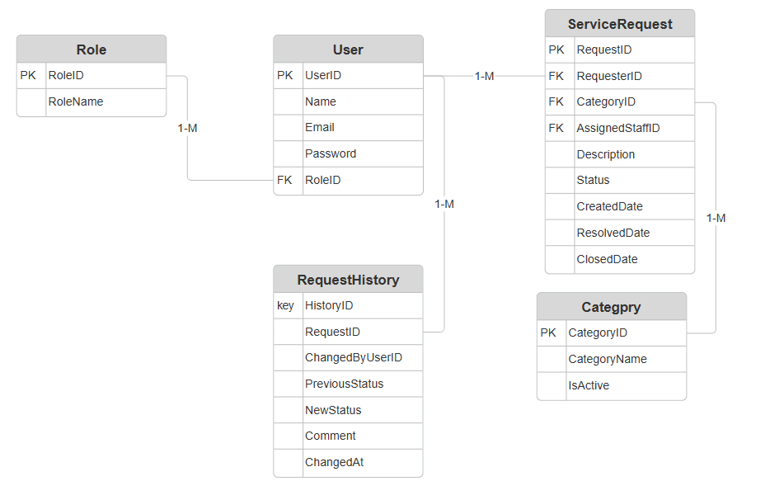

Entity relationship:
Relationship | cardinality | Reason
Role to User | 1:M | One role can apply to multiple users.
User to ServiceRequest(requester) | 1:M | A requester can submit multiple service requests
Category to ServiceRequest | 1:M | A category can contain multiple service requests
User to ServiceRequest(assigned staff member) | 1:M | A staff member can be assigned multiple service requests
ServiceRequest to RequestHistory | 1:M | A request can have multiple history entries
User to ServiceRequest | 1:M | A user can make multiple recorded changes

Ownership:
Entity | Lifecycle
Role | Controlled reference data which will be managed by authorized administration
User | Represents an account along with its assigned role
Service Request | Functions as a central business entity with a lifecycle from submission to resolution.
Request History | Dependent on service requests and tracks changes throughout its lifecycle.
Category | Controlled reference data which will be managed by authorized administration

Persistence decisions

Requirements driving the persistence decision:
The M1 baseline is the source of the following requirements
- Organized connections between users, requests, history, and categories
- Distinct identifiers for service requests
- Regulated categories
- Lifecycle and status tracking
- Auditable history
- Role-based access
- Dependable storage
- Management reporting
- Request filtering by category/status
- Atomic creation and modification of request data
- Protection of sensitive data
- Potential expansion
The team considered the following alternatives:

Relational database(such as PostgreSQL, MySQL, SQL server):
The advantages are as follows:
- Structured schema
- Foreign-key relationships
- Referential integrity
- Constraints
- Transactions
- Appropriate for request/history relationships
- Appropriate for managing reports and queries

Document database(MongoDB):
The advantages are as follows:
- Adaptable document structure
- Simple document shape modification
- Appropriate for applications where data is inherently document-oriented

Recommended decision:
The recommended persistence method for CivicConnect is relational persistence. The organized relationships and integrity constraints mentioned in M1 are a perfect fit for a PostgreSQL relational database.
PostgreSQL transactions are made up of multiple SQL statements which are combined into a single, atomic unit of work. This process protects the database from incomplete data changes and corruption by guaranteeing that either all operations are fully successful or none of them take effect (PostgreSQL, 2026). Within PostgreSQL foreign-key constraints connect two tables and maintain referential integrity. It guarantees that a value in a child table’s column corresponds to a value in a parent table’s main key or unique column. PostgreSQL offe3rs two core methods for backing up data, namely, logical and physical backups. Physical backups duplicate the actual data files that PostgreSQL uses, whereas logical backups generate SQL statements that can replicate your database’s structure and data (Pawale, 2026).
Overall, PostgreSQL was chosen over the other relational database systems because it satisfies CivicConnect’s anticipated data and reporting requirements while offering the necessary relational features, robust referential integrity, transaction support, and dependable backup capabilities. It also proved to be the more sensible option for the project’s development and deployment requirements because it is open-source and does not require licensing.

Data integrity and transaction decision:
Upon receiving a service request the system must generate the following:
- The service request
- Its original status
- The creation date
- Relevant metadata
- And its initial requestHistory record.
The appropriate manner to handle these activities it to treat them as a single business activity. CivicConnect may have an unfinished audit trail if the request is created successfully but its original history is not documented.
The validation responsibilities for the system must be separate. The UI must be utilized for basic input validation, the service/business layer for handling business rules and transactions, whilst the database manages structural constraints and integrity of data.

The proposed flow should be as follows:
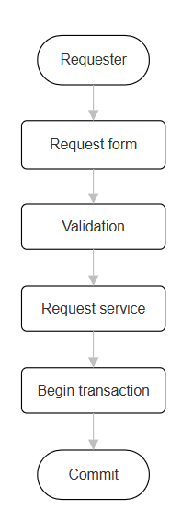

Technology stack:
For CivicConnect, the chosen technological stack is made up of C# with ASP.NET Core for the backend and application runtime, React for the frontend and PostgreSQL for persistence. The Npgsql PostgreSQL supplier will supply the application-to-database data access layer for Entity Framework Core. Automated unit testing will be done with xUnit, and build and test automation will be provided by GitHub actions. The M1 requirements for role-based access, service request management, status/history monitoring, auditability, reporting, data integrity, and maintainability are all supported by this stack.

Area | Selected technology | Reason
Frontend | React framework | CivicConnect requires several interactive views for requesters, staff, management, and administrators, including service-request forms, status updates, filtering, request history, and management reports. React was chosen because these interfaces can be created as reusable components thanks to React’s component based architecture, which promotes consistency and maintainability throughout the application.
Backend | ASP.NET core MVC/C# | This decision offers an organized application architecture that can be used to divide persistence, business logic, and presentation. Additionally, CivicConnect’s requester, staff, management and admin roles are directly supported by ASP.NET Core’s built-in authentication and authorization features.
Persistence | PostgreSQL | The structured relationships between users, roles, categories, service requests, and request history in CivicConnectare best served by a relational database. Data integrity may be maintained via PostegreSQL’s constraints and transaction features.
Data access | Entity framework core + Npgsql | Reduces the amount of database-access code that needs to be written by hand while offering PostegreSQL a data-access layer that is compatible with .Net.
Testing | xUnit | Offers a simple framework for automated business logic and service unit testing.
Build management | .NET SDK+ NuGet | This choice gives the chosen C#/.NET stack a standard build and dependency-management procedure. Through the project settings, dependencies can be reliably restored and version pinned.
CI | GitHub actions | It can automatically build and test pull requests, giving visual verification results prior to merging, and it works with the team’s current GitHub workflow.
Deployment | ASP.NET Core + PostgreSQL | Instead of relying on a proprietary database or specialized runtime, the chosen technologies can be deployed as a conventional ASP.NET Core web application with a PostgreSQL database.

Comparison project constraints:
CivicConnect’s functional requirements, team competency, timetable, and budget constraints were taken into consideration when choosing the technology stack. The interactive role-specific interfaces needed for M1, such as request submission, status viewing, filtering, and management dashboards, are supported by React. A structured backend for business logic, authentication, and role-based access control can be implemented using C# and ASP.NET Core. PostgreSQL was chosen because CivicConnect has data-integrity standards and defined relationships, and its open-source licensing eliminatwes the need for additional database licensing fees. Development and dependency risk are also decreased by using well-known tools like Entity Framework Core, Npgsql, npm and NuGet. Lastly, the technologies may be connected with GitHub actiosnand the team’s current GitHub process, making the stack feasible to develop within the project’s timeline.

Version, compatibility and security assumptions:
The project will employ PostgreSQL 18 for persistence, React 19 for the front end, and.NET 10 or ASP.NET Core 10 for the back end. While Entity Framework Core with Npgsql will enable compatibility between the.NET application and PostgreSQL, frontend and backend dependencies will be managed by npm and NuGet, respectively, with versions documented in the project files to guarantee consistent development environments. The frontend and backend will communicate via HTTP-based APIs.
Throughout development, compatible stable versions and security updates will be implemented. While input validation, parameterized database access, and PostgreSQL constraints will be utilized to lower common data and injection threats, ASP.NET Core will manage authentication and role-based authorization. Additionally, the group will steer clear of superfluous dependencies and check dependency updates for security and compatibility issues before adoption.

Decision and risk management
An Architecture Decision Record (ADR) will document the chosen technology stack and the alternatives taken into consideration, along with the rationale behind each technology's selection and the pertinent compatibility assumptions. Risks including team familiarity, dependency compatibility, security flaws, and deployment concerns will be addressed by updating the project risk registry. During development, any major modifications to the technology stack will be compared to the initial specifications and recorded in a revised ADR.

Technology Architectural Design Record’s:

ADR-001: React frontend
CivicConnect necessitates a flexible web interface that supports various roles and interactive features, such as staff assignment, management reporting, status viewing, request history, and service request submission. Therefore, maintainability and reusable user interface components must be supported by the frontend technology while staying within the team’s development timeline and skill development.
Frameworks considered:
- Blazor
- Plain Html/CSS/Javascript
- Angular
- React
- Other frameworks used for frontend
Decision:
React was chosen because interactive role-specific interfaces and reusable UI components are supported by its component-based architecture. It offers CivicConnect enough capability without necessitating the intricacy of a more elaborate application architecture.

Positive outcomes:
- Reusable components
- Ideal for dashboards and interactive forms
- Extensive documentation and ecosystem
- Keeps backend AP and frontend duties separate.
Negative outcomes:
- Adds more dependencies than just basic Javascript
- Calls for team to learn more about npm and react.
Risk:
Maintaining compatible React and npm dependencies is essential, as is checking major dependency updates for compatibility or security flaws.

ADR-002: C#/ASP.NET Core backend
For the administration of service requests, status changes, authentication, role-based access control, validation, and database interaction, CivicConnect needs backend business logic. In addition to being appropriate for the team's skills and project timeline, the backend must provide a maintainable architecture.
Frameworks considered:
- C#/ASP.NET Core
- Node.js / express
- Other server-side frameworks
Decision:
Because it offers an organized framework for executing the application's business logic, authentication, and role-based authorization, C# with ASP.NET Core was chosen. Additionally, it has direct integration with PostgreSQL and Entity Framework Core.
Positive outcomes:
- Durable business logic framework
- Supports role-based access control and authentication
- PostgreSQL with Entity Framework core integration
Negative outcomes:
- Requires familiarity of the .Net ecosystem
- Greater structure within the framework than a basic Node.js/Express program
Risk;
The project is contingent on the chosen versions of Entity Framework Core, Npgsql, and.NET remaining compatible during development. Dependency versions will be controlled, and major updates will be reviewed before adoption because updates to these dependencies may cause compatibility problems or necessitate code changes.

ADR-003: PostgreSQL Relational Persistence
Using M1 data-integrity needs and structural relationships between entities like Users, Roles, Categories, Service Requests, and Request History were identified. Reliable reporting, transactions, and referential integrity must all be supported by the persistence system.
Databases considered:
- PostgreSQL
- MySQL
- MongoDB
Decision:
CivicConnect's structured relationships make PostgreSQL an excellent choice for relational persistence. In order to preserve consistent data, PostgreSQL offers transactions, foreign-key restrictions, and other database constraints. Additionally, it saves additional database licensing fees because to its open-source licensing.
Positive outcomes:
- Strong integrity between relationships
- Supports transactions
- Ideal for structured queries and reporting
- No extra fee for database licensing
- EF core compatibility via Npgsql
Negative outcomes:
- Requires well defined schema for relationships
- Migrations must be used to handle schema changes
Risk:
The chosen PostgreSQL version must continue to work with the database schema and migrations. Entity Framework Core and the Npgsql provider will be used for database access.

Updated RTM
Requirement | Persistence impact | Design | Technology | Implementation evidence | Verification
FR-001 | ServiceRequest + initial RequestHistory | Request creation service | React + ASP.NET Core + PostgreSQL | Endpoint + models | Planned
FR-002 | Category FK | Controlled category entity | ASP.NET Core + PostgreSQL | Category model and schema | Planned
FR-003 | RequestID PK | Unique request identifier | PostgreSQL + EF core | Schema/model | Planned
FR-004 | ServiceRequest.Status | Request retrieval | React + ASP.NET Core + PostgreSQL | Status endpoint | Planned
FR-005 | RequestHistory | Request history relationship | React + ASP.NET Core + PostgreSQL | History model | Planned
FR-006 | RequestHistory | Status-change handling | ASP.NET Core + PostgreSQL | Status service | Planned
FR-010 | AssignedStaffID | Assignment responsibility | React + ASP.NET Core + PostgreSQL | Assignment endpoint | Planned
FR-011 | Status + RequestHistory | Controlled status transition | ASP.NET Core + PostgreSQL | Status service | Planned
FR-012 | RequestHistory | Action/comment recording | React + ASP.NET Core + PostgreSQL | History model | Planned
FR-014 | RequestHistory | Management activity query | React + ASP.NET Core + PostgreSQL | Management query | Planned
FR-015 | Status + dates | Reporting queries | React + ASP.NET Core authorisation+ PostgreSQL | Reporting API | Planned
NFR-019 | User/Role + access rules | RBAC architecture | ASP.NET Core + PostgreSQL | Role implementation | Planned
NFR-020 | RequestHistory/audit data | Audit trail | ASP.NET Core + PostgreSQL | History implementation | Planned
NFR-022 | Persistent ServiceRequest | Transaction persistence | PostgreSQL + EF core | Migration + transaction logic | Planned
NFR-024 | Database/application response | Performance-aware architecture | React + ASP.NET Core + PostgreSQL | Query/API implementation | Planned

Design, Development & Governance — Milestone 2

A. Design Problems and Pattern Decisions
The problems discussed come from M1 baseline requirements for CivicConnect. The record format follows Nygard (2011). The problem is stated before pattern is named as well as project specific decision is record with is benefit and cost. The previous ADR is used as evidence

A.1 Design Problem 1 — Controlled request status lifecycle (DP-1)
Context: M1 2.1 defines a transition, for giving requesters honest visibility. FR-011 requires only verified transitions to be recorded while FR-013 lets authorised staff resolve or close. NFR-018 restricts actions by role.
Problem: These rules that determine legal or permissible transitions are used in multiple places, example: staff updates, resolve/close., if they are written as scattered conditions, one code path will eventually allow an illegal move. This could cause a corruption in the history that FR-014, FR-015 and NFR-020 depend on. Thus, we need to design the system to keep the rules in one place, which can be tested thoroughly
Lifecycle rules: Only 7 of the 36 transitions are legal in this case. Closed or rejected are terminal. The right-hand column records the policy that the rule must implement. While the authorisation, is decided outside of the lifecycle
From | To | Required input | Authorisation policy (Identity & Access) | Reqs
Submitted | Acknowledged | — | Authorised staff | FR-011, FR-006
Submitted | Rejected | Reason | Authorised staff | FR-011, FR-006
Acknowledged | In Progress | Assignee set | Assigned staff member | FR-010, FR-011
Acknowledged | Rejected | Reason | Authorised staff | FR-011, FR-006
In Progress | Resolved | Resolution note | Assigned staff member | FR-012, FR-013
Resolved | Closed | — | Authorised staff | FR-013
Resolved | In Progress (reopen) | Reason | Authorised staff | FR-011

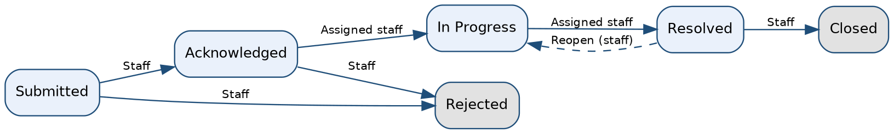
Figure A1 — Legal status transitions (solid = forward path, dashed = reopen). Matches PED §4.3.

ADR-006 — Use the State pattern for the request lifecycle
Field | Record
Status / date / owner | Proposed | 30/9/2026 | Person 3 (Accepted when the M2 baseline is signed)
Decision | Model each status as a state object behind a RequestState interface. ServiceRequest.transitionTo(target, actor, note) first asks Identity & Access whether the actor may act (ADR-003), then delegates to its current state, which either accepts the target and supplies the new state or rejects it with a reason. The change and its audit record are then committed together (ADR-004, ADR-005). States decide legality and required inputs; they never inspect roles.
Alternatives considered | (a) Conditional logic (if/else or switch) in the request service: simplest to write, but this is the form of code the State pattern is designed to replace when behaviour depends on state (Gamma et al., 1994, pp. 305–313; Freeman and Robson, 2020).  (b) Data-driven transition table (map of from/to/required input): also centralised and lighter than State, and the closest alternative.  (c) State pattern (chosen).
Why (c) over (b) | Transitions carry behaviour as well as permission: terminal states reject everything, In Progress requires an assignee, and Rejected/Resolved/Reopen require a note. Per-state classes keep that behaviour cohesive and testable one state at a time. Team judgement, to be defended at the presentation: a table would need extra condition code for the same cases.
A2 evidence | The pattern is documented by PED/ADR observer-based reactions are displayed in application code. Separate validation procedures are displayed by PED/ADR and application code. PED/ADR, data model and application transaction/validation logic. PED/ADR, architecture diagram and application interface implementation. Repository settings, PR history, CI workflow/results and project documentation.
Benefit | One owner for lifecycle rules (NFR-023, ASR-4); adding a status touches one class; each rule is unit-testable without a database (ASR-2 requires invalid transitions to be rejected 100% of the time in tests).
Complexity / trade-off | Gamma et al. (1994, pp. 305–313) note that State spreads behaviour over more classes than one conditional would and is worthwhile mainly when there are many states. Six states is near the lower limit, so this cost is real. Mitigation: states are stateless and shared, no framework is added, and ServiceRequest depends only on the interface, so falling back to option (b) is a contained change.
Affected components | Request Management: ServiceRequest, RequestState and concrete states, RequestService; the transitions endpoint (B.2); StatusHistory persistence; reporting queries for open/overdue.
If reversed | RTM rows FR-010, FR-011, FR-013 (design, implementation, verification), the transition test suite, Figures A1/A2, R10 and README module notes would change. The API contract in B.2 would not.
Traceability | FR-010, FR-011, FR-013, NFR-018, NFR-020, NFR-023; ASR-2, ASR-4; ADR-003, ADR-004; risks R6, R10.

A.2 Design Problem 2 — Audit trail and requester feedback on every status change (DP-2)

Context: NFR-020 require major changes to be tracked. It requires a status, and responsible staff member to be added. FR-006 only needs feedback from the request when the status get changed. M1 3.3 we decided to defer SMS/emails, so in-app pop ups and notifications are within scope but other channels are expected later on for ASR-4. ADR-004 is a fix for the rule that allows audit record to be written with the same transaction as the change. It prevents the end user to be connected to each part of every lifecycle.

Problem: When successful change is completed a audit record and requester-visible update must be produced. This applies to every code path that changes a request. This is to provide a robust change log and support debugging. But if a Request Management calls audit and notification code directly, the core lifecycle is coupled to both processes. A new change means editing core present/future code will forget a call silently and breaks auditability. The audit record must never be missing when a change is committed.

ADR-005 — Use the Observer pattern (synchronous, in-process) for status-change side effects
Field | Record
Status / date / owner | Proposed | 30/9/2026 | Person 3 (this is the ADR-005 candidate Person 1 asked the team to assign)
Decision | On a successful change, Request Management publishes a StatusChanged (or AssignmentChanged) event through RequestEventPublisher, which notifies subscribed RequestEventListeners (Gamma et al., 1994, pp. 293–303). Two listeners are registered in one composition point: AuditTrailListener (Audit module; appends a StatusHistory row) and NotificationListener (Notification module; records an in-app update through a NotificationChannel). Both run synchronously inside the same unit of work as the change (Fowler, 2002), so the transaction either commits all of it or none (Kleppmann, 2017, ch. 7). This is the mechanism that realises ADR-004; it is not the asynchronous “separate process or event” that ADR-004 rejected.
Dependency direction | The event types and RequestEventListener interface are part of Request Management’s published interface. Audit and Notification implement that interface and never call Request Management back, in line with Person 1’s rule that dependencies point inward (Martin, 2017) and rule 3 in PED §4.1. Confirm rule 3 is intended to permit implementing a published listener interface; if not, move the event contract into a small shared kernel and update ADR-002.
Extension point (ASR-4) | The Notification module exposes a NotificationChannel interface. An in-app channel is implemented now; email/SMS (M1 §3.3, deferred) become new channel classes attached after commit, so an external outage cannot block staff work.
Alternatives considered | (a) Direct calls from Request Management to audit and notification code: least indirection, but coupling and the forgotten-call risk above.  (b) Asynchronous queue or message broker (Hohpe and Woolf, 2003): decouples fully, but adds infrastructure and eventual consistency, which works against “exactly one audit record per change” (Newman, 2021) and is disproportionate for a three-person team on a free-tier assumption (M1 §4).  (c) Database triggers for audit: rejected in ADR-004 (logic hidden from code review, harder to test); also cannot produce requester updates.  (d) Observer, in-process and synchronous (chosen).
A2 evidence | The pattern is documented by PED/ADR observer-based reactions are displayed in application code. Separate validation procedures are displayed by PED/ADR and application code. PED/ADR, data model and application transaction/validation logic. PED/ADR, architecture diagram and application interface implementation. Repository settings, PR history, CI workflow/results and project documentation.
Audit content | Each history row records who, what and when: actor, request, from-status, to-status, timestamp and note, following the event attributes recommended for security logging (OWASP Foundation, n.d.a). Rows are append-only (ADR-004).
Benefit | Lifecycle code no longer knows about auditing or notification (ASR-4, NFR-023); a new channel is a new class; the audit guarantee is enforced in one place; listeners are testable in isolation.
Complexity / trade-off | Gamma et al. (1994, pp. 293–303) note that observers add indirection and can produce unexpected cascading updates, so control flow is harder to follow. Listener order and failure behaviour must be documented. Synchronous listeners add latency to each change; the NFR-024 target (95% of regular operations within 3 seconds, as clarified by CR-001) is expected to hold at this scale and will be measured in M3. Failure rule: if the audit write fails, the change is rolled back, deliberately favouring accountability (M1 §1.1). Mitigation: only two listeners and a test that fails if the audit listener is not registered.
Affected components | Request Management (RequestService, publisher, listener interface), Audit (AuditTrailListener, StatusHistory), Notification (NotificationListener, NotificationChannel), history and notifications endpoints (B.2).
If reversed (e.g. to a queue) | The transaction rule, the deployment footprint (extra service), R11, README run instructions, Person 2’s persistence ADR and NFR-022/NFR-024 verification would change; so would ADR-004 and RTM rows FR-006, FR-014, NFR-020.
Traceability | FR-006, FR-012, FR-014, NFR-020, NFR-022, NFR-023; ASR-2, ASR-4; ADR-002, ADR-004; risk R11.

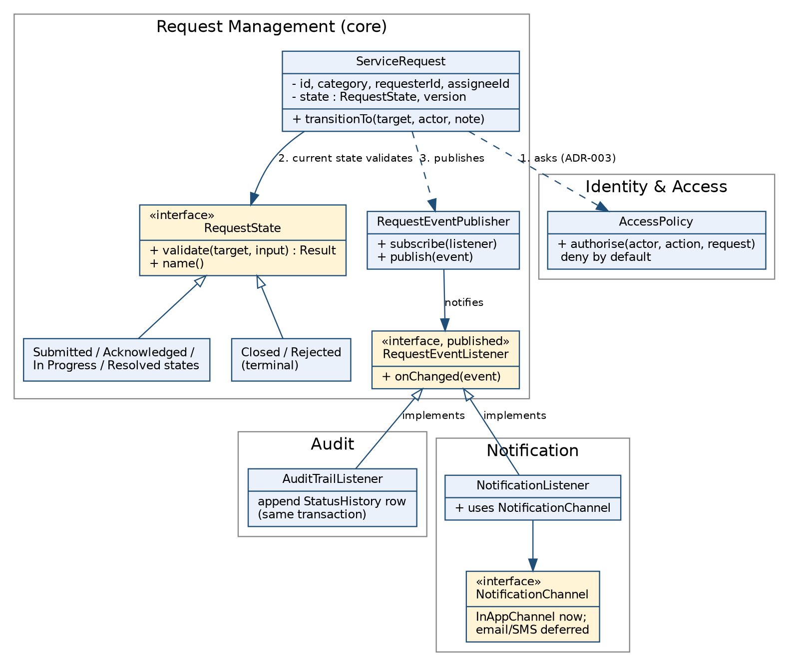
Figure A2 — Design diagram: State (DP-1) and Observer (DP-2) across the Request Management, Identity & Access, Audit and Notification modules.

A.3 How the two decisions work together
A transition request runs in this order: authenticate, authorise through Identity & Access (ADR-003), validate through the current state (ADR-006), apply the change and publish the event inside one transaction (ADR-004, ADR-005). If authorisation or the state rejects the request, nothing is published, so the history contains only verified transitions, which is the acceptance criterion of FR-011 and the ASR-2 target.
Initial application evidence: Lifecycle evidence lives under the “feature/status-lifecycle” branch on the repo.

B. Interface / API Decisions

B.1 Boundaries and mechanism
CivicConnect has one genuine network boundary: the browser client talking to the application server (PED §4.4). The six modules are logical units inside one deployable, so calls between them are ordinary in-process calls through published interfaces (ADR-002). No microservice or external integration is created, consistent with the M1 exclusion of third-party/municipal integrations and the brief’s proportionality rule.
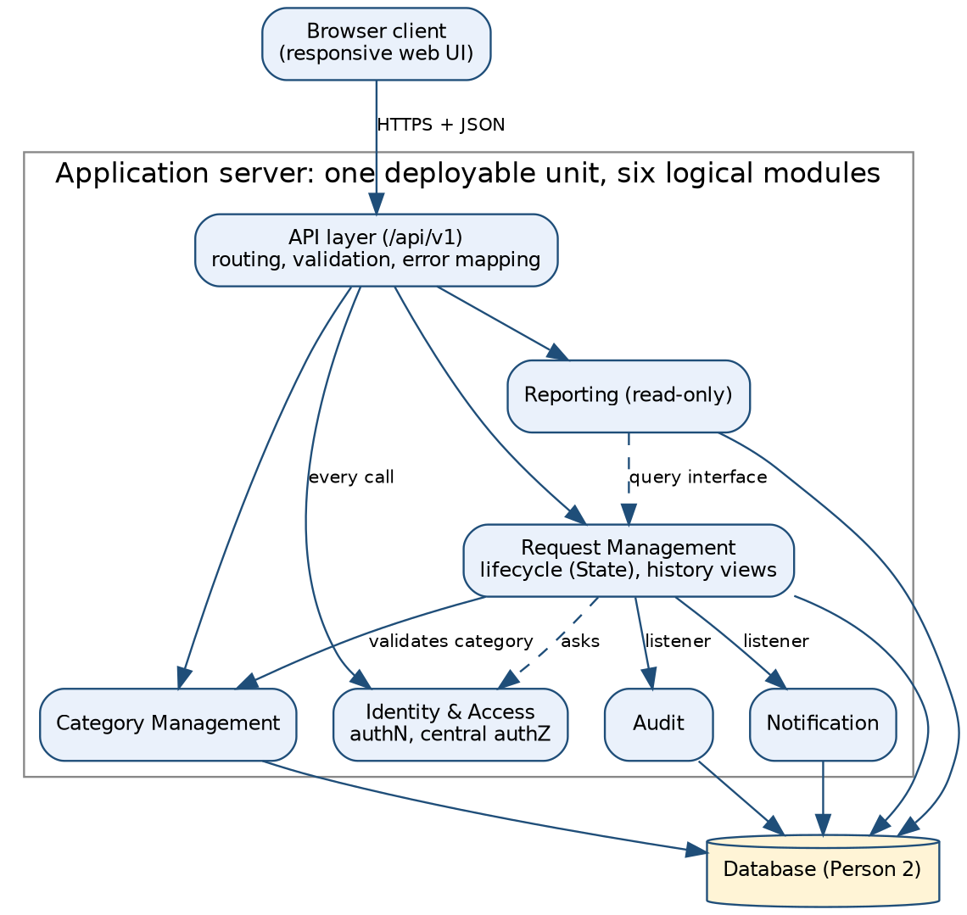
Figure B1 — Modules and the single network boundary (browser ↔ API layer).

ADR-007 — Resource-oriented JSON API over HTTPS, versioned under /api/v1
Field | Record
Status / date / owner | Proposed | 30/9/2026 | Person 3
Decision | A resource-oriented API in the REST style (Fielding, 2000, ch. 5) using standard HTTP methods and status codes (Fielding, Nottingham and Reschke, 2022). The major version is in the URL path (/api/v1), the approach used in Google’s published versioning guidance (Google, n.d.). Actions that are not simple updates (assignment, status transition) are sub-resources so lifecycle and access rules are always applied server-side. The contract is written as an OpenAPI description (OpenAPI Initiative, 2021) kept in the repository. Errors use the RFC 9457 problem-details format (Nottingham, Wilde and Dalal, 2023).
Alternatives considered | GraphQL (GraphQL Foundation, 2021): flexible queries, but extra tooling and a harder per-field authorisation surface for a small, fixed set of screens. RPC-style endpoints: simple, but a poorer fit to requests as resources. Server-rendered form posts: valid if Person 2 selects a server-rendered stack; the service contract in B.2 stays the same and only the outermost layer changes.
A2 evidence | The pattern is documented by PED/ADR observer-based reactions are displayed in application code. Separate validation procedures are displayed by PED/ADR and application code. PED/ADR, data model and application transaction/validation logic. PED/ADR, architecture diagram and application interface implementation. Repository settings, PR history, CI workflow/results and project documentation.
Benefit | Predictable, easy to test and document; maps directly onto FR-001 to FR-016; authorisation and validation are enforced in one place (ASR-1); a machine-readable contract supports later contract tests.
Trade-off | Several small endpoints and a versioning obligation; some screens need more than one call, which is acceptable at this scale.
If reversed | B.2 endpoint table, the OpenAPI file, README API section, RTM interface column, client code, contract tests and R12.
Traceability | FR-001 to FR-016, NFR-017 to NFR-019, NFR-021; ASR-1, ASR-5; ADR-001, ADR-003.

B.2 Initial endpoint contract
Roles: Req = Requester, Stf = Staff, Mgt = Management/Admin. Authentication (NFR-017) applies to every endpoint; the mechanism is a technology decision ADR-001 to ADR-004. Every endpoint passes through Identity & Access, and every endpoint that takes an object identifier checks that the caller may access that object, the weakness ranked first in the OWASP API Security Top 10 (OWASP Foundation, 2023).
Method & path | Purpose / payload | Roles | Reqs | Success / key errors
POST /api/v1/requests | Create request: category id, description, details | Req | FR-001, 002, 003 | 201 + id; 400/422 missing field or unknown category
GET /api/v1/requests | List with filters: status, category, priority, text search, sort | Req (own only), Stf, Mgt (in scope) | FR-004, 005, 007, 008, 016 | 200; out-of-scope rows never returned
GET /api/v1/requests/{id} | Full request detail | Req (own), Stf, Mgt | FR-004, 009 | 200; 403 / 404
POST /api/v1/requests/{id}/assignment | Accept or assign owner | Stf (authorised) | FR-010 | 200; 403; 409 already assigned
POST /api/v1/requests/{id}/transitions | Body: target status, note, expected version | Stf (policy in A.1) | FR-011, 013 | 200; 409 illegal transition or stale version; 403; 422 note missing
POST /api/v1/requests/{id}/comments | Add action / resolution note; internal flag | Stf | FR-012 | 201; 403
GET /api/v1/requests/{id}/history | Status and ownership history | Req (own, non-internal entries), Stf, Mgt | FR-005, 014, NFR-020 | 200; internal notes hidden from requester (NFR-019)
GET /api/v1/notifications | In-app status updates for the caller | Req | FR-006 | 200
GET /api/v1/categories | Controlled category list | All authenticated | FR-002 | 200
POST/PUT /api/v1/categories | Maintain category list | Admin | FR-002 | 201/200; 403
GET /api/v1/reports/requests-summary | Open / overdue / resolved / closed counts by category and status | Mgt | FR-014, 015, 016 | 200; 403 for non-management. “Overdue” depends on CR-002

B.3 Cross-cutting interface rules
Concern | Decision (level currently known)
Validation | Server-side for every write: required fields, category must exist in the controlled list, note required for Reject/Resolve/Reopen, lengths bounded. Client checks are convenience only (NFR-021).
Error / failure behaviour | Errors are returned as application/problem+json (Nottingham, Wilde and Dalal, 2023) with the standard members (type, title, status, detail, instance) plus two extension members: errors[] for field-level validation messages and correlationId for support. Status codes follow HTTP semantics (Fielding, Nottingham and Reschke, 2022): 400 malformed, 401 unauthenticated, 403 not permitted, 404 not found or deliberately not disclosed (the RFC allows 404 in place of 403 to hide existence), 409 conflict (illegal transition, stale version), 422 semantic validation failure, 500 with no internal detail. A rejected transition returns the reason supplied by the state object.
Security boundary | Authentication on every route; role and ownership checks made by Identity & Access (ADR-003), deny by default, so a direct API call cannot bypass RBAC. Object-level and function-level checks are both required (API1 and API5 in OWASP Foundation, 2023). Requester queries are filtered to own records; internal comments are stripped from requester responses (NFR-019). No secrets in the repository (D.4).
Concurrency | Transition and assignment calls carry an expected version. A stale value returns 409, so two staff cannot silently overwrite each other; this is the optimistic offline lock described by Fowler (2002).
Change / version | Additive changes (new optional field, new endpoint) stay in v1; removing, renaming or retyping a field is breaking and requires a new major version plus an ADR/change record (Google, n.d.). The OpenAPI description lives at docs/api/openapi.yaml: Status deferred for future implementation.
Deferred (recorded, not invented): pagination limits, rate limiting, external notification channels and any integration with outside systems. See H.3.

C. Application Documentation and Repository Structure
The README is delivered as a separate repository file (README.md) prepared with this document. It must match the code and this PED. Configuration guidance in it follows the twelve-factor practice of keeping configuration in the environment (Wiggins, 2017).
Required item (M2 brief §8) | Where covered | Status
Purpose, current implementation status | README §1–2 | Drafted; update status each merge
Prerequisites, runtime and dependency versions | README §3 | Fill from Person 2 stack ADR and authoritative sources
Setup and run instructions | README §4 | Drafted with placeholders for stack commands
Repository structure mapped to modules | README §5 and table below | Drafted; adjust to real folders
Database / schema / migrations | README §6 | Pending Person 2 ERD and migration tool
Interfaces / API endpoints | README §7, docs/api/openapi.yaml | Drafted from B.2
Environment / configuration without secrets | README §8, .env.example | Drafted
Module responsibilities and design-pattern application | README §9 | Drafted from A and B
Testing, limitations, TODOs | README §10–11 | Drafted; must reflect real tests
Links to PED / RTM / ADRs | README §12 | Add links once PED v2.0 is in the repository

C.1 Repository structure aligned to the architecture (Person 1 modules)
Module (PED §4.1) | Proposed location | Published interface / notes
Identity & Access | identity_access/ | AccessPolicy.authorise(actor, action, resource); deny by default
Request Management (core) | request_management/ | Lifecycle (RequestState classes), RequestService, RequestEventPublisher and RequestEventListener
Category Management | category_management/ | Category lookup and validation interface
Audit | audit/ | AuditTrailListener; append-only StatusHistory; no update/delete path
Notification | notification/ | NotificationListener, NotificationChannel (in-app now)
Reporting | reporting/ | Read-only query interface over Request Management data
API layer, client, docs, CI | api/, client/, docs/, .github/ | API layer contains no business or authorisation rules
Folder names mirror the modules so that dependency violations are visible in code review (ADR-002).
Code documentation rule (team). Comment intent, not mechanics. Every state class states which transitions it permits and why; every listener states its failure behaviour; each endpoint handler and test names the requirement it serves (for example // FR-011). Tagging code with requirement IDs keeps traceability followable in both directions, from requirement to code and from code back to requirement (Gotel and Finkelstein, 1994).

D. GitHub Governance & Repository Evidence
M1 governance is retained unchanged: protected main, no direct pushes, pull requests required, two approvals, stale approvals dismissed, most recent push approved by someone other than the pusher, linear history, force pushes blocked and deletions restricted. GitHub documents these as branch protection rules that enforce required reviews and passing status checks before merge (GitHub Docs, n.d.a). Repository: https://github.com/Armand-JV/SEN381-Project. Members: Armand Vermeulen (Armand-JV), Riegardt Weich (xStoffer), Ditheto Phaho (Deee-dot).

D.1 M2 working conventions
Area | Convention
Issues | One issue per task, labelled by area (docs, design, api, data, governance, test), linked to the RTM requirement ID, all in the M2 milestone.
Branches | As per M1: feature/<name-or-id>, bugfix/<issue-id>; add docs/<name> for PED, README and RTM changes and chore/<name> for tooling.
Commits | Short imperative subject with the requirement or issue reference, e.g. Add ResolvedState transition rules (FR-013, #14) (imperative subject lines: Beams, 2014). Commit as work is done; no bulk uploads.
Pull requests | Template asks: what changed, linked issue, requirement/ADR IDs, how it was tested, whether AI assisted and how it was verified, and whether docs were updated. Documentation and RTM changes are reviewed like code.
Reviews | Every substantive PR needs both other team members (two independent approvals). Empirical work on code review at Microsoft found that, besides finding defects, review spreads knowledge and team awareness (Bacchelli and Bird, 2013), which is why all three members review. Turnaround target: 48 hours. Reviewers also enforce Person 1’s “no cross-module internals” checklist item (ADR-002).
Changes to baselined decisions | A new ADR supersedes the old one; the old ADR stays, marked Superseded with the reason. No silent rewrites.

ADR-008 — Adopt minimal automated checks now; defer a mature pipeline
Field | Record
Status / date / owner | Proposed | 30/9/2026 | Person 3
Decision | Adopt now: a GitHub Actions workflow (GitHub Docs, n.d.c) that builds the project and runs the automated tests on every pull request, set as a required status check (already the intent of M1); .gitignore, .env.example, PR and issue templates. Merging small changes frequently onto a tested mainline is the core of continuous integration (Fowler, 2006).
Secret and dependency protection | Enable secret scanning with push protection and dependency alerts where the repository supports them. GitHub documents secret scanning as available for public repositories, and for organisation-owned repositories only with an additional paid product (GitHub Docs, n.d.b). GitHub visibility set to public with only contributors access to change repo.
Deferred | Coverage thresholds, deployment automation, container builds, static-analysis gates and release tagging: these are the later stages of a deployment pipeline (Humble and Farley, 2010). Evidence needed: Person 2’s deployment decision and a stable test suite.
A2 evidence | Use pull requests, protected main, feature branches, 2 approvals, and CI quality gates.
Benefit / trade-off | Fast, free feedback that protects main. Cost: workflow maintenance, and a flaky build blocks two-approval merges (R13).
If reversed | README testing section, PR template, R13 and the RTM verification column.

D.2 Evidence checklist (M1 items carried forward, M2 items added)
Evidence | Status | Where to point the assessor
Repository created; protected main (M1 rules) | Done | https://github.com/Armand-JV/SEN381-Project/settings/rules/22544388
Issues and task board for M2 | Open | https://github.com/Armand-JV/SEN381-Project/issues
Feature branches for design, API, docs and code | Open | https://github.com/Armand-JV/SEN381-Project/branches
Pull requests with two independent approvals | Done | https://github.com/Armand-JV/SEN381-Project/pull/2
Review of documentation PRs (PED, RTM, README) | Done | https://github.com/Armand-JV/SEN381-Project/pull/1
Progressive commit history by all members | Done | https://github.com/Armand-JV/SEN381-Project/graphs/contributors?from=6%2F27%2F2026
CI workflow running on PRs | Done | https://github.com/Armand-JV/SEN381-Project/actions/workflows/test.yml
No secrets committed; .env not present | Done | https://github.com/Armand-JV/SEN381-Project
README and technical docs present and current | Drafted (Section C) | https://github.com/Armand-JV/SEN381-Project/blob/main/README.md

D.3 Contribution record
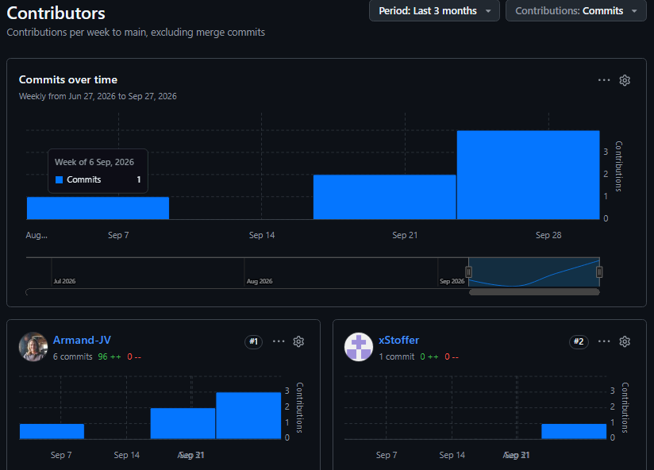

D.4 Secrets and configuration
Configuration is read from environment variables at start-up; configuration that varies between deployments belongs in the environment, not in code (Wiggins, 2017). .env is git-ignored and .env.example lists names with dummy values only. Secrets are never committed, following OWASP’s secrets-management guidance (OWASP Foundation, n.d.b); a credential committed by mistake is treated as compromised and rotated, not merely deleted from history.

E. RTM v2.0 — Design/Interface, Implementation and Verification Columns
The RTM continues from M1 (same IDs and wording). Person 1’s ASR link and architecture module columns and Person 2’s data and technology columns merge in by requirement ID. The columns below are Person 3’s. Status uses controlled values: Approved (baselined, not started), In Development, Implemented, Changed, Deferred. Implementation evidence names the planned artefact and is replaced by the real branch/PR/file once it exists; verification is Planned until a test exists. The aim is a matrix that can be followed from requirement to code and back (Gotel and Finkelstein, 1994). Planned tests follow the test-pyramid idea of many fast unit tests and fewer integration tests (Fowler, 2012).
ID | Design / interface decision | Implementation evidence | Verification evidence | Status | ADR / risk
FR-001 | B.2 POST /requests; server-side validation | Create-request handler + validation; «PR» | Planned: VT-001 missing field rejected; valid creates request | Approved | ADR-007; ASR-3
FR-002 | B.2 GET /categories; category must exist | Category validation; «PR» | Planned: VT-002 unknown/absent category rejected | Approved | ADR-007
FR-003 | Identifier generated by persistence layer | Request id on create; «PR» | Planned: VT-003 ids unique | Approved | ADR-007; ASR-3
FR-004 | B.2 list/detail; ownership filter | Query with requester filter; «PR» | Planned: VT-004 requester sees only own | Approved | ADR-003, 007; R6
FR-005 | B.2 list and /history | History view; «PR» | Planned: VT-005 previous requests listed | Approved | ADR-005, 007
FR-006 | DP-2 Observer; notifications endpoint | NotificationListener, InAppChannel; «PR» | Planned: VT-006 notification row per accepted transition | Approved | ADR-005; R11
FR-007 | Central authorisation (ADR-003); B.2 list | Visibility policy; «PR» | Planned: VT-007 out-of-scope request unavailable | Approved | ADR-003, 007; R6
FR-008 | B.2 list filters and sort | Filter/sort parameters; «PR» | Planned: VT-008 results match selected attribute | Approved | ADR-007; ASR-5
FR-009 | B.2 GET /requests/{id} | Detail handler; «PR» | Planned: VT-009 all attributes returned | Approved | ADR-003, 007
FR-010 | B.2 assignment; owner recorded | Assignment handler; «PR» | Planned: VT-010 unauthorised change refused; assignee stored | Approved | ADR-003, 006, 007
FR-011 | DP-1 State; B.2 transitions | RequestState + concrete states, transitions handler; «branch/PR» | Planned: VT-011 7 legal transitions accepted, 29 rejected; role cases | In Development «confirm» | ADR-004, 006; R10
FR-012 | B.2 comments; internal flag | Comment handler; «PR» | Planned: VT-012 note stored and retrievable | Approved | ADR-005, 007
FR-013 | DP-1 Resolved/Closed states | ResolvedState, ClosedState; «PR» | Planned: VT-013 resolve/close visible to requester | Approved | ADR-006
FR-014 | DP-2 history; B.2 /history, /reports | AuditTrailListener + history query; «PR» | Planned: VT-014 ownership change visible to management | Approved | ADR-004, 005
FR-015 | B.2 /reports/requests-summary | Summary query; «PR» | Planned: VT-015 counts correct (needs CR-002 overdue rule) | Approved | ADR-007; CR-002
FR-016 | B.2 list and report filters | Filter parameters; «PR» | Planned: VT-016 filter by category/status | Approved | ADR-007
NFR-017 | B.3 authentication on every route | Auth middleware; «PR» | Planned: VT-017 unauthenticated call refused | Approved | ADR-003, 007
NFR-018 | Central authorisation; DP-1 order of checks | AccessPolicy; «PR» | Planned: VT-018 wrong role refused, right role allowed | Approved | ADR-003, 006; R6
NFR-019 | B.3 internal notes stripped for requesters | Response filtering; «PR» | Planned: VT-019 requester cannot retrieve internal note | Approved | ADR-003, 007; R6
NFR-020 | DP-2 mandatory audit listener in same transaction | AuditTrailListener, StatusHistory; «branch/PR» | Planned: VT-020 change writes history; failed audit rolls back | In Development «confirm» | ADR-004, 005; R11
NFR-021 | B.3 validation and problem-details errors | Validation messages, confirmation response; «PR» | Planned: VT-021 invalid input gives clear message | Approved | ADR-007
NFR-022 | DP-2 unit of work; persistence per Person 2 | Persistence layer; «PR» | Planned: VT-022 stored request retrievable after restart | Approved | ADR-004, 005; R8
NFR-023 | Modules per Figure B1; patterns per A | Repository structure mirrors modules; «PR» | Planned: review checklist on every PR | Approved | ADR-001, 002, 005, 006; R10
NFR-024 | Synchronous listeners kept light | n/a until M3 load check | Planned (M3): timing test, 95% within 3 s (CR-001) | Approved | ADR-005; ASR-5; R9

E.1 End-to-end trace (required demonstration): FR-011
This is the path Person 1 suggested (PED §7), completed with Person 3’s decisions. Highlighted items need real repository evidence.
Step | Evidence
Requirement | FR-011: authorised staff update requests through controlled, verified transitions (Staff; High).
 | ASR-2 (trustworthy lifecycle and audit trail); ASR-1 for who may act; M1 Quality and Security constraints; risks R6, R10.
Architecture responsibility | Request Management (lifecycle) with Audit and Identity & Access (PED §4.1); API layer only maps HTTP to service calls (Figure B1).
Data decision | Append-only StatusHistory written in the same transaction (ADR-004) and a version field on the request for optimistic concurrency.
Design / interface decision | ADR-006 State pattern; ADR-005 Observer for audit; ADR-007 POST /api/v1/requests/{id}/transitions.
Technology / ADR | React Frontend, ASP.NET C# backend. PostgreSQL database. ADR-008 for the automated check that runs the tests.
Initial verification | VT-011: all 7 legal transitions accepted for an authorised actor; the other 29 ordered pairs rejected; requester and unassigned staff refused; exactly one history row per accepted transition and none for a rejected one.

F. Risk Register v2.0
Person 3 owns the register. M1 risks R1–R4 are preserved with an M2 review note; Person 1’s architecture risks R5–R9 are merged unchanged; Person 3’s new risks continue from R10. Person 2 adds data, technology, deployment and cost risks from R19. Priority uses the M1 scale (Critical / High / Medium / Low).

F.1 M1 risks — M2 review
ID | Risk | Priority | M2 review note | Status
R1 | Stakeholder requirements change after baseline | Critical | Controlled through CR-001 to CR-003 and ADR supersession; any requirement change updates RTM and this register. | Open
R2 | Poor Git collaboration causes conflicts | High | Conventions in D.1 tighten branch and commit practice; conflicts to date. | Open — monitored
R3 | Security requirements overlooked | High | Addressed by ADR-003 and B.3 (central server-side authorisation); see R6. Verification still Planned, so remains open | Open
R4 | Schedule delays from unequal workload | Medium | See R17; contribution table D.3 added as monitoring evidence | Open

F.2 Architecture risks contributed by Person 1 (merged unchanged)
ID | Risk | Prob. | Impact | Priority | Mitigation | Owner | Contingency | Status
R5 | Module boundaries erode inside the monolith | Medium | Medium | Medium | ADR-002 rules, PR checklist item, folder structure mirrors modules | Architecture lead | Refactoring task before next milestone | Open
R6 | Access control bypassed through an endpoint that skips the central check | Medium | High | High | ADR-003; authorisation tests per endpoint; review checklist | Team | Security review and fix before release; log as change | Open
R7 | Architecture over-engineered relative to team capacity | Low | Medium | Low | Proportionality principle (ADR-001); revisit if a module has no independent reason to exist | Architecture lead | Merge modules via controlled ADR change | Open
R8 | Single application instance and single database are single points of failure; no availability target | Medium | Medium | Medium | Persist-then-confirm (ASR-3); backup approach (Person 2); availability deferred | Team | Restore from backup; document recovery steps | Open
R9 | Free-tier hosting limits conflict with ASR-5 or ASR-3 | Medium | Medium | Medium | Record limits as dependency assumption (M1 Cost constraint); measure early | Person 2 | Move to paid tier or simplify reporting queries | Open

F.3 New risks from design, interface, governance and implementation (Person 3)
ID | Risk | Prob. | Impact | Priority | Mitigation | Owner | Contingency | Status
R10 | State and Observer patterns add complexity beyond what six states and two listeners justify (Gamma et al., 1994) | Medium | Medium | Medium | Stateless shared states; only two listeners; review against ADR-005/006; low-cost fallback to a transition table | Person 3 | Supersede the ADR and replace state classes behind the same interface | Open
R11 | Audit or notification write fails, causing lost history or blocked staff actions | Medium | High | High | Audit in same transaction (ADR-004/005); test that fails if the audit listener is unregistered; external channels only after commit | Person 3 with Person 2 | Reconcile from request table; documented manual correction procedure | Open
R12 | API contract drifts between UI and backend | Medium | Medium | Medium | OpenAPI description as the contract (OpenAPI Initiative, 2021); versioning rule; contract tests once UI exists | Person 3 | Freeze v1 fields; change via ADR | Open
R13 | Two-approval rule or a failing CI check stalls merges when a member is unavailable | Medium | Medium | Medium | 48-hour review target; small PRs; reviewers rotate; keep the workflow simple | Team | Recorded temporary change to approvals via change control, then restored | Open
R14 | Secrets or credentials committed to the repository (OWASP Foundation, n.d.b) | Low | High | High | .gitignore, .env.example, secret scanning if available, PR checklist | Person 3 | Rotate credential immediately; document incident | Open
R15 | AI-generated code, text or references merged without genuine verification | Medium | High | High | AI Register with verification evidence (G); PR template asks about AI use; each member explains their own code; sources opened and checked | Team | Rewrite or remove unverified material; note in register | Open
R16 | README, PED, RTM and code diverge | Medium | Medium | Medium | Docs updated in the same PR as code; RTM reviewed each merge | Person 3 | Documentation sync PR before assessment | Open
R17 | Contribution evidence is uneven or bulk-committed near the deadline | Medium | High | High | Weekly review of D.3; issues assigned per member; commit as work is done | Team | Reassign tasks and record in change log (links to R4) | Open
R18 | Later A2 evidence contradicts a baselined design decision | Low | Medium | Medium | ADRs cite A2 sources; decisions reversible behind interfaces | Team | Controlled change: new ADR supersedes, old kept with reason | Open

G. AI Usage Register v2.0
M1 entries are retained. New entries cover the AI assistance used for these Person 3 sections and for suggesting sources. Verification stays Pending until the named person has actually done the check; do not mark it complete before then.
Date | Artefact | AI use | Human verification
07 September | Risk Register | Table Structure | Confirmed project requirements match table structure (Edited)
07 September | Forward Engineering Considerations | Strictly Consideration column | Researched common considerations for similar projects
08 September | Engineering Decision Log | Decision confirmation by AI review | Decisions created by Engineer
30 September | DP-1 / DP-2 problem statements; ADR-005, ADR-006 | AI drafted problem framing, alternatives, ADR wording and diagram source | Pending: Person 3 to check alternatives against A2 sources, confirm the decisions are the team’s own and be able to explain them
30 September | Interface / API decisions; ADR-007 | AI drafted endpoint table, error format and rules | Pending: check against Person 1 architecture and Person 2 stack; confirm each endpoint traces to an FR
30 September | GitHub governance section D; ADR-008 | AI drafted conventions and templates | Pending: confirm settings and plan features match the repository
30 September | README and application documentation | AI drafted structure and text | Pending: run setup on a clean machine; fix versions and commands against authoritative sources
30 September | RTM columns; Risk Register R10–R18 and merge of R5–R9 | AI drafted rows, test identifiers, risks | Pending: replace planned evidence with real links; team review of probability, impact, ownership
30 September | In-text citations and Section I references (Person 3 sections) | AI suggested sources; existence and details of seven sources were checked online during drafting (see I.2) | Pending: each member opens the sources they cite, confirms the sentence is supported, checks page numbers, and enters access dates
30 September | Person 1’s references (Section 10 of their draft) | AI-suggested sources flagged by Person 1 for checking | Pending: Person 1 to verify; Person 3 to record the outcome here

H. Version History, Decision Log and Open Items

H.1 Version history (extends the M1 and Person 1 tables)
Version | Date | Author | Changes
0.1 | 06 September | Armand | Work split and format (M1)
0.8 | 08 September | Team | Each member integrates sections (M1)
1.0 | 09 September | Team | Verified baseline for submission (M1)
1.1 | 09 September | Riegardt | M1 review findings logged as CR-001 to CR-003
1.8 | 30 September | Armand and Ditheto | Design problems, ADR-005 to ADR-008, interface decisions, RTM design/implementation/verification columns, risks R10–R18 and merge of R5–R9, AI Register, governance updates, citations.
2.0 | 30 September | Team | Architecture, Technology & Initial Design Baseline approved

H.2 Engineering Decision Log (extends the M1 table; Person 1 ADRs shown for completeness)
ID | Decision | Status | Reason
D1 | Use GitHub controlled repository | Accepted (M1) | Source control and governance
D2 | Tech stack | Accepted | Evidence for team experience and collaboration
D3 | Database design | Deferred in M1; «superseded by Person 2 ADR-__» | «Person 2 entry»
D4 | Requirement IDs follow FR/NFR numbering | Accepted (M1) | Traceability
ADR-001 to ADR-004 | Modular monolith; module rules; central authorisation; lifecycle + audit in one transaction | Proposed (Person 1) | See PED §5
ADR-005 | Observer (synchronous, in-process) for audit and notification | Proposed/ | Decoupling with the ADR-004 audit guarantee (DP-2)
ADR-006 | State pattern for request lifecycle | Proposed | Central, testable lifecycle rules (DP-1)
ADR-007 | Resource-oriented JSON API under /api/v1, RFC 9457 errors | Proposed | One proportionate network boundary
ADR-008 | Minimal CI checks now, mature pipeline deferred | Proposed | Progressive adoption per brief §10

H.3 Deliberately deferred decisions and evidence still needed
Deferred decision | Evidence required before deciding
External notification channels (email/SMS) | Cost and provider limits (Person 2); demonstrated need beyond in-app updates; approved change request
Asynchronous events / message queue | Measured load or failure evidence that synchronous listeners are insufficient
Pagination limits and rate limiting | Real list sizes and hosting limits
Management override of status transitions | Stakeholder confirmation that management may act on requests (M1 treats management as view/report)
Category maintenance endpoints (admin) | Team decision whether to add an FR for the M1 System Administrator need
Mature CI/CD (coverage gates, deployment) | Stable test suite and Person 2 deployment decision
Performance verification of NFR-024 | M3 load/timing test on the chosen host, using the load defined under CR-001

H.4 Baseline sign-off (M2 Architecture, Technology & Initial Design Baseline)
Person 3 items in the baseline: ADR-005 to ADR-008, B.2 endpoint contract v1, repository structure (C.1), RTM v2.0 columns, Risk Register v2.0. Open items: H.3.
Team member | Role | Signature | Date
Riegardt Weich | Architecture & Quality Drivers |  | 30 September
Ditheto Lesiba Phaho | Data, Persistence & Technology |  | 30 September
Armand Vermeulen | Design, Development & Governance |  | 30 September

I. References

I.1 Reference list (Harvard)
Merge with Person 1’s and Person 2’s lists in the PED Sources section and remove duplicates. Entries marked with an access date in square brackets need the team’s own date after opening the source.
Bacchelli, A. and Bird, C. (2013) ‘Expectations, outcomes, and challenges of modern code review’, Proceedings of the 35th International Conference on Software Engineering (ICSE), San Francisco, 18–26 May. Piscataway, NJ: IEEE, pp. 712–721. doi:10.1109/ICSE.2013.6606617.
Beams, C. (2014) How to write a git commit message. Available at: https://cbea.ms/git-commit/ (Accessed: 30 September 2026).
Fielding, R.T. (2000) Architectural styles and the design of network-based software architectures. PhD dissertation. University of California, Irvine. Available at: https://ics.uci.edu/~fielding/pubs/dissertation/top.htm (Accessed: 30 September 2026).
Fielding, R.T., Nottingham, M. and Reschke, J. (eds) (2022) HTTP semantics. RFC 9110. Internet Engineering Task Force. Available at: https://www.rfc-editor.org/info/rfc9110 (Accessed: 30 September 2026).
Fowler, M. (2002) Patterns of enterprise application architecture. Boston: Addison-Wesley.
Fowler, M. (2006) ‘Continuous integration’, martinfowler.com, 1 May. Available at: https://martinfowler.com/articles/continuousIntegration.html (Accessed: 30 September 2026).
Fowler, M. (2012) ‘TestPyramid’, martinfowler.com, 1 May. Available at: https://martinfowler.com/bliki/TestPyramid.html (Accessed: 30 September 2026).
Freeman, E. and Robson, E. (2020) Head First design patterns. 2nd edn. Sebastopol, CA: O’Reilly Media.
Gamma, E., Helm, R., Johnson, R. and Vlissides, J. (1994) Design patterns: elements of reusable object-oriented software. Reading, MA: Addison-Wesley.
GitHub Docs (n.d.a) About protected branches. Available at: https://docs.github.com/en/repositories/configuring-branches-and-merges-in-your-repository/managing-protected-branches/about-protected-branches (Accessed: 30 September 2026).
GitHub Docs (n.d.b) Introduction to secret scanning. Available at: https://docs.github.com/en/code-security/secret-scanning/introduction (Accessed: 30 September 2026).
GitHub Docs (n.d.c) GitHub Actions documentation. Available at: https://docs.github.com/en/actions (Accessed: 30 September 2026).
Google (n.d.) ‘AIP-185: API versioning’, API Improvement Proposals. Available at: https://google.aip.dev/185 (Accessed: 30 September 2026).
Gotel, O.C.Z. and Finkelstein, A.C.W. (1994) ‘An analysis of the requirements traceability problem’, Proceedings of the First International Conference on Requirements Engineering, Colorado Springs, 18–22 April. Los Alamitos, CA: IEEE Computer Society Press, pp. 94–101.
GraphQL Foundation (2021) GraphQL specification, October 2021. Available at: https://spec.graphql.org/October2021/ (Accessed: 30 September 2026).
Hohpe, G. and Woolf, B. (2003) Enterprise integration patterns: designing, building, and deploying messaging solutions. Boston: Addison-Wesley.
Humble, J. and Farley, D. (2010) Continuous delivery: reliable software releases through build, test, and deployment automation. Upper Saddle River, NJ: Addison-Wesley.
Kleppmann, M. (2017) Designing data-intensive applications. Sebastopol, CA: O’Reilly Media.
Martin, R.C. (2017) Clean architecture: a craftsman’s guide to software structure and design. Upper Saddle River, NJ: Prentice Hall. (Also in Person 1’s list.)
Newman, S. (2021) Building microservices: designing fine-grained systems. 2nd edn. Sebastopol, CA: O’Reilly Media. (Also in Person 1’s list.)
Nottingham, M., Wilde, E. and Dalal, S. (2023) Problem details for HTTP APIs. RFC 9457. Internet Engineering Task Force. Available at: https://www.rfc-editor.org/info/rfc9457 (Accessed: 30 September 2026).
Nygard, M. (2011) ‘Documenting architecture decisions’, Cognitect Blog, 15 November. Available at: https://www.cognitect.com/blog/2011/11/15/documenting-architecture-decisions (Accessed: 30 September 2026). (Also in Person 1’s list.)
OpenAPI Initiative (2021) OpenAPI specification v3.1.0. Available at: https://spec.openapis.org/oas/v3.1.0 (Accessed: 30 September 2026).
OWASP Foundation (2023) OWASP API security top 10 – 2023. Available at: https://owasp.org/API-Security/editions/2023/en/0x11-t10/ (Accessed: 30 September 2026).
OWASP Foundation (n.d.a) Logging cheat sheet. Available at: https://cheatsheetseries.owasp.org/cheatsheets/Logging_Cheat_Sheet.html (Accessed: 30 September 2026).
OWASP Foundation (n.d.b) Secrets management cheat sheet. Available at: https://cheatsheetseries.owasp.org/cheatsheets/Secrets_Management_Cheat_Sheet.html (Accessed: 30 September 2026).
Wiggins, A. (2017) The twelve-factor app. Available at: https://12factor.net/ (Accessed: 30 September 2026).

I.2 Verification status of these sources
Group | What was confirmed | What the team must still do
RFC 9110, RFC 9457, GitHub Docs (protected branches; secret scanning), Google AIP-185, OWASP API Security project, Bacchelli and Bird (2013) | Existence, authors, titles, dates and the general content were checked online on 30 September 2026 while drafting. Secret-scanning availability wording comes from the GitHub page. Bacchelli and Bird pages and DOI matched. | Open each, confirm the sentence it supports, check section numbers (e.g. RFC 9110 §15.5), and confirm the OWASP edition URL opens.
Books: Gamma et al.; Freeman and Robson; Fowler (2002); Kleppmann; Hohpe and Woolf; Humble and Farley; Martin; Newman | Standard, widely cited works cited from established knowledge; not opened during drafting. | Check chapter and page numbers against your copy or library record (pages given for Gamma et al. are pattern chapters: State pp. 305–313, Observer pp. 293–303), and edition details.
Fielding (2000); Gotel and Finkelstein (1994); Fowler (2006, 2012); Beams (2014); OpenAPI; GraphQL; Wiggins; OWASP cheat sheets; GitHub Actions docs | Cited from established knowledge; URLs not opened during drafting. | Open each URL, confirm it loads and supports the claim, and enter your own access date.

Sources are used only where they support a specific claim in the text. If a source cannot be opened or does not support its sentence, remove the citation and reword the sentence rather than keeping an unsupported reference.

9. M2 Architecture, Technology & Initial Design Baseline (Person 1 sign-off section)
Person 1 owns baseline sign-off; contents from Persons 2 and 3 are merged here.
Baseline identifier: CivicConnect M2 Baseline, PED v2.0, dated [date].
Included in the baseline:
- M1 requirements baseline as amended by CR-001 to CR-003 (once approved)
- ASR-1 to ASR-5 (Section 2)
- Architecture decision and diagrams (Sections 3 and 4); ADR-001 to ADR-004
- [Person 2: data model, persistence decisions, technology stack ADRs]
- [Person 3: two design-pattern decisions, interface decisions, repository structure]
- RTM v2.0 and Risk Register entries R1 to R9
Open or deferred (separately identified): see Section 8; plus [Person 2/3 open items].
Change control after baseline: any material change to an ADR follows the controlled process: new ADR marked as superseding the old one, reason recorded, affected RTM rows and risks updated, two-reviewer PR.
Team member | M2 role | Signature | Date
Riegardt Weich | Architecture & Quality Drivers
[Person 2] | Data, Persistence & Technology
[Person 3] | Design, Development & Governance

10. References
All in-text citations above use (Author, year). Add these to the PED Sources section alongside the M1 sources, which remain unchanged. The M1 entries already in the PED and reused here are: American National Standards Institute/INCITS (2004), ISO/IEC (2011), Republic of South Africa (2013), Sandhu, Ferraiolo and Kuhn (2000), Bass, Weber and Zhu (2015).
Bass, L., Clements, P. and Kazman, R. (2021) Software architecture in practice. 4th edn. Boston: Addison-Wesley.
Brown, S. (n.d.) The C4 model for visualising software architecture. Available at: https://c4model.com (Accessed: [date]).
Evans, E. (2004) Domain-driven design: tackling complexity in the heart of software. Boston: Addison-Wesley.
Fowler, M. (2002) Patterns of enterprise application architecture. Boston: Addison-Wesley.
Fowler, M. (2015) 'MonolithFirst', martinfowler.com, 3 June. Available at: https://martinfowler.com/bliki/MonolithFirst.html (Accessed: [date]).
Kruchten, P. (1995) 'The 4+1 view model of architecture', IEEE Software, 12(6), pp. 42–50.
Martin, R.C. (2017) Clean architecture: a craftsman's guide to software structure and design. Upper Saddle River, NJ: Prentice Hall.
Newman, S. (2021) Building microservices: designing fine-grained systems. 2nd edn. Sebastopol, CA: O'Reilly Media.
Nygard, M. (2011) 'Documenting architecture decisions', Cognitect Blog, 15 November. Available at: https://www.cognitect.com/blog/2011/11/15/documenting-architecture-decisions (Accessed: [date]).
OWASP Foundation (2021) OWASP Top 10:2021, A01 Broken Access Control. Available at: https://owasp.org/Top10/A01_2021-Broken_Access_Control/ (Accessed: [date]).
Richards, M. and Ford, N. (2020) Fundamentals of software architecture: an engineering approach. Sebastopol, CA: O'Reilly Media.
Verification note: these are real, standard sources, but they were suggested with AI assistance. Before submission, open each one and confirm that it actually supports the sentence it is attached to, check edition and publisher details against your copy or library record, fill in your own access dates, and record this in the AI Usage Register (Person 3 maintains it). The M2 brief requires claims first obtained through AI to be checked against authoritative sources.

